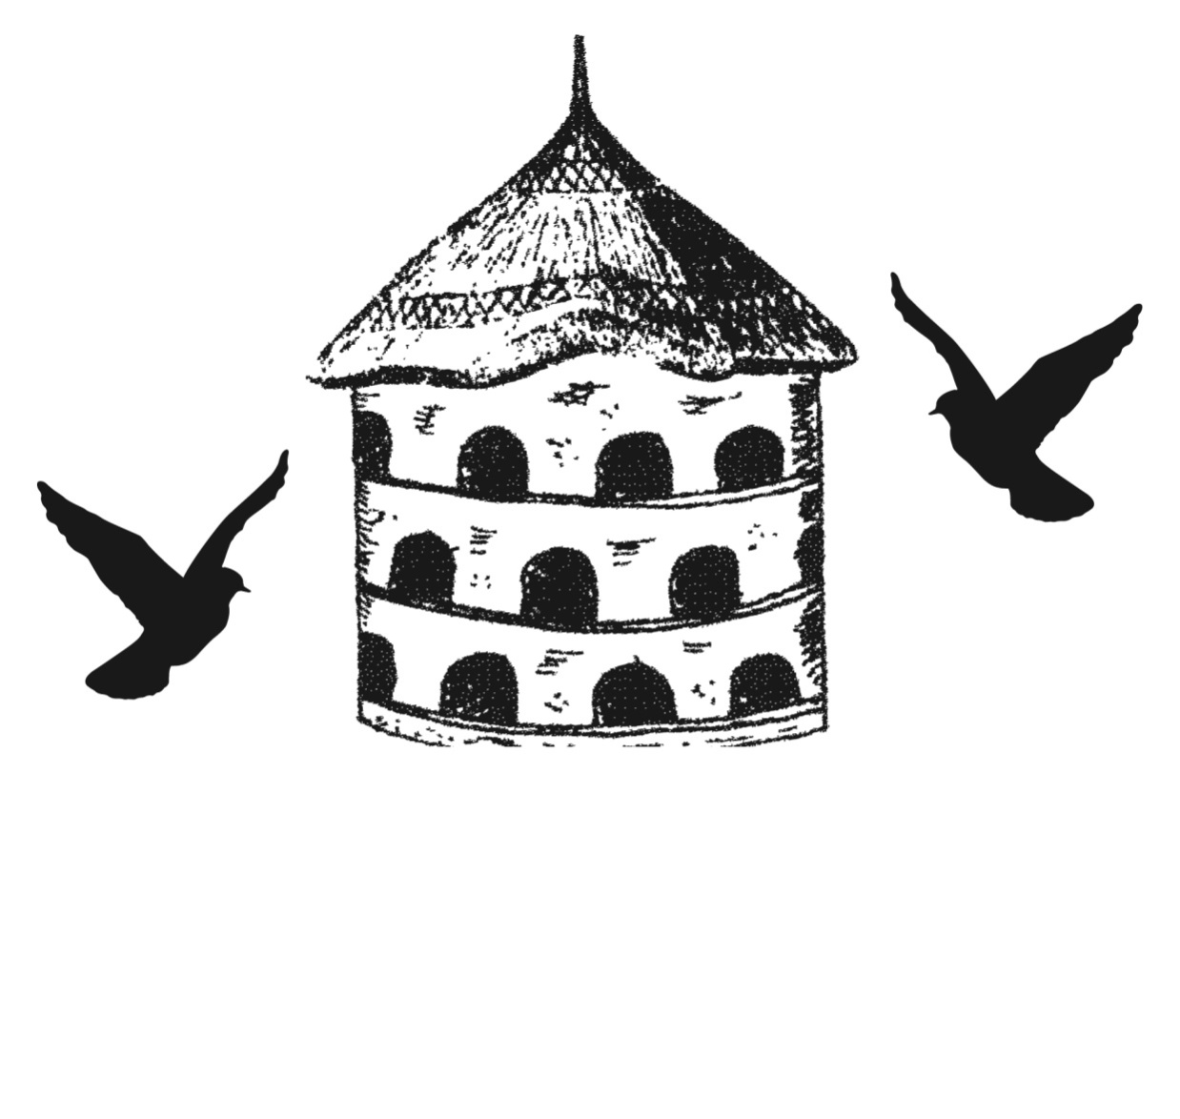

The Dovecote Buttery

Cakes served all day
Breakfast : 10 – 11:30
Main courses & Jacket Potatoes : 12 – 15:00
Salads & Sandwiches : 11 – 15:30

If you require any advice on allergies, please don’t hesitate to as ask a member of the team

Drinks
Soft Drinks
£1.50
Coke
Diet Coke

Water
£2.50
Sparkling Water
Still Water
Raspberry Sparkling Water

Hot Drinks

Fresh Ingredient Tea
2.90
Tea/Specialist Tea
£2.60
Filter Coffee/Americano
£2.50
Espresso
£2.50
Cappuccino
£3.20
Latte/Iced Latte
£3.20
Baileys Coffee
£4.50
Hot Chocolate
£3.50
Hot Chocolate,Cream & Marshmallows
£4.50

Luscombe Organic Juices
£3.25

Orange Juice
Wild Elderflower Bubbly
Sicilian Lemonade
Ginger Beer
Passion & Ginger
Apple
Sparkling Apple
Apple & Pear
Raspberry Crush

Jazz up your coffee with delicious shot of
Specialist coffee syrups for just 50p
Amaretto, Vanilla, Hazelnut or Caramel

Main Courses

Lamb Shanks
slow cooked lamb shank in minted gravy with creamy mashed potato and vegetables
£16.50
Sausage & Mash
seven wells lincolnshire sausages with creamy mashed potato, balsamic roast red onion and vegetables
£11.90
Pie of the Day
Pieminister/suet pudding pie with house mushy peas, mashed potato, sauce and vegetables
£13.50
Catch of the Day
Please ask a member of the team about our fish dish of the day
£ Market Price
Roasted Chicken Breast
Roast breast of chicken served with new potatoes or mash, vegetables and a whiskey mushroom sauce
£13.90
Vegetarian Quiche
mixed vegetable quiche served with salad and new potatoes
£9.75
Vegan dish of the Day
Please ask a member of staff about our vegan dish of the day
£10.90

Salads
ALL SERVED WITH FRESH CRUSTY BREAD

Chicken Caesar Salad
crispy gem lettuce, homemade croutons, grilled chicken slices, caesar dressing and plenty of parmesan and garlic bread
£9.90
Goats Cheese Salad
goats cheese slices, fresh figs and sundried tomatoes with a sticky fig infused balsamic glaze
£10.90
Why not add an extra filling to your Salad or Sandwich for just £2.00
Bacon
Chicken
Prawns
Tuna
Smoked Salmon
Avocado
Brie
Prawns – Lemon Dressing
icelandic prawns in a lemon mayonnaise dressing
£9.50
Feta, Black Olive & Sundried Tomato
greek feta crumbled over fresh salad with black olives and sundried tomatoes
£8.90
Chicken & Bacon
grilled chicken and chopped bacon
£8.90

Sandwiches
ALL SERVED WITH SALAD, AND HOMEMADE NEW POTATO SALAD
All £7.90
Sandwiches
Tuna Mayonnaise
tuna flakes with peppery mayo
Brie – Bacon – Mango Chutney
creamy brie with crispy bacon & a side of mango chutney
B.L.T
classic bacon, lettuce and tomato with mayo

Fish Fillet
Breaded fish fillet with tartar sauce
Prawn – Rocket – Lemon
icelandic prawns tossed in a lemon mayonnaise dressing & peppery rocket

Wraps & Sandwiches
Tomato - Mozzarella - Basil (v)
thick tomato slices with mozzarella & fresh basil pesto
Cheese – Pickle (v)
mature cheddar cheese with chunky farmhouse chutney
Chicken and Cranberry
grilled chicken with lettuce and cranberry sauce
Avocado – Roast Red Pepper (VGN)
smashed avocado with roast red peppers

Why not try our Dovecote 50/50?
add a mug of our soup of the day for just £2.50

Jacket Potatoes
ALL SERVED WITH SALAD GARNISH

Cheese – Onion/Beans/Coleslaw (v)
mature cheddar cheese with either: red onion slices, baked beans or coleslaw
£6.95
Chilli – Cheese – Sour Cream
homemade chilli with grated cheddar cheese and sour cream
£8.50
Three bean Chilli – Cheese – Sour Cream (V)
Homemade three bean chilli with grated cheddar cheese and sour cream
£8.50
Prawns – Lemon Dressing
icelandic prawns in a lemon mayonnaise dressing
£8.50
Spinach, Sundried Tomato & Feta (V)
crumbled feta cheese with sundried tomatoes and fresh spinach
(vegan cheese available as a substitute to feta cheese)
£7.90

Tea Room Treats

Dovecote Farm Cream Tea
Originally served out of a wooden hut during strawberry season, our cream teas are served with a large scone, fruit or plain, homemade homegrown strawberry jam and clotted cream with tea or filter coffee
£5.75

Hot Dessert of the Day served with cream or custard

Dovecote High Tea
A selection of sandwiches, cakes and baby scone with jam and clotted cream with tea or coffee
Our afternoon teas require advanced booking and are ideal for baby showers, hen do’s or just a gathering with old friends
£16.50/person
Or… Why not add a glass of prosecco?
£20.50

Please view our chilled display cabinet for our selection of homemade cakes and gateaux’s

Breakfast

Dovecote Full English
seven wells lincolnshire sausage, bacon, eggs your way, mushrooms
and tomatoes served with toast & homemade marmalade
£9.95
A Healthier option?
Muesli with fresh milk and fresh fruit
£3.90
Fresh Fruit with natural greek yogurt and a squeeze of honey
£5.90
Avocado and Poached egg on toast
£6.90
Smoked Salmon & Scrambled egg on toast
£6.90

extras
double up
avocado
beans
black pudding
£2.00

Dovecote Vegetarian Breakfast
avocado, halloumi, eggs your way, mushrooms and tomatoes with toast and homemade marmalade
£9.95
Three Bean Chilli (v/vgn)
Three bean chilli on toast with poached eggs or sweet potato hash (Vegan)
£7.90

CAUTION

slippy

