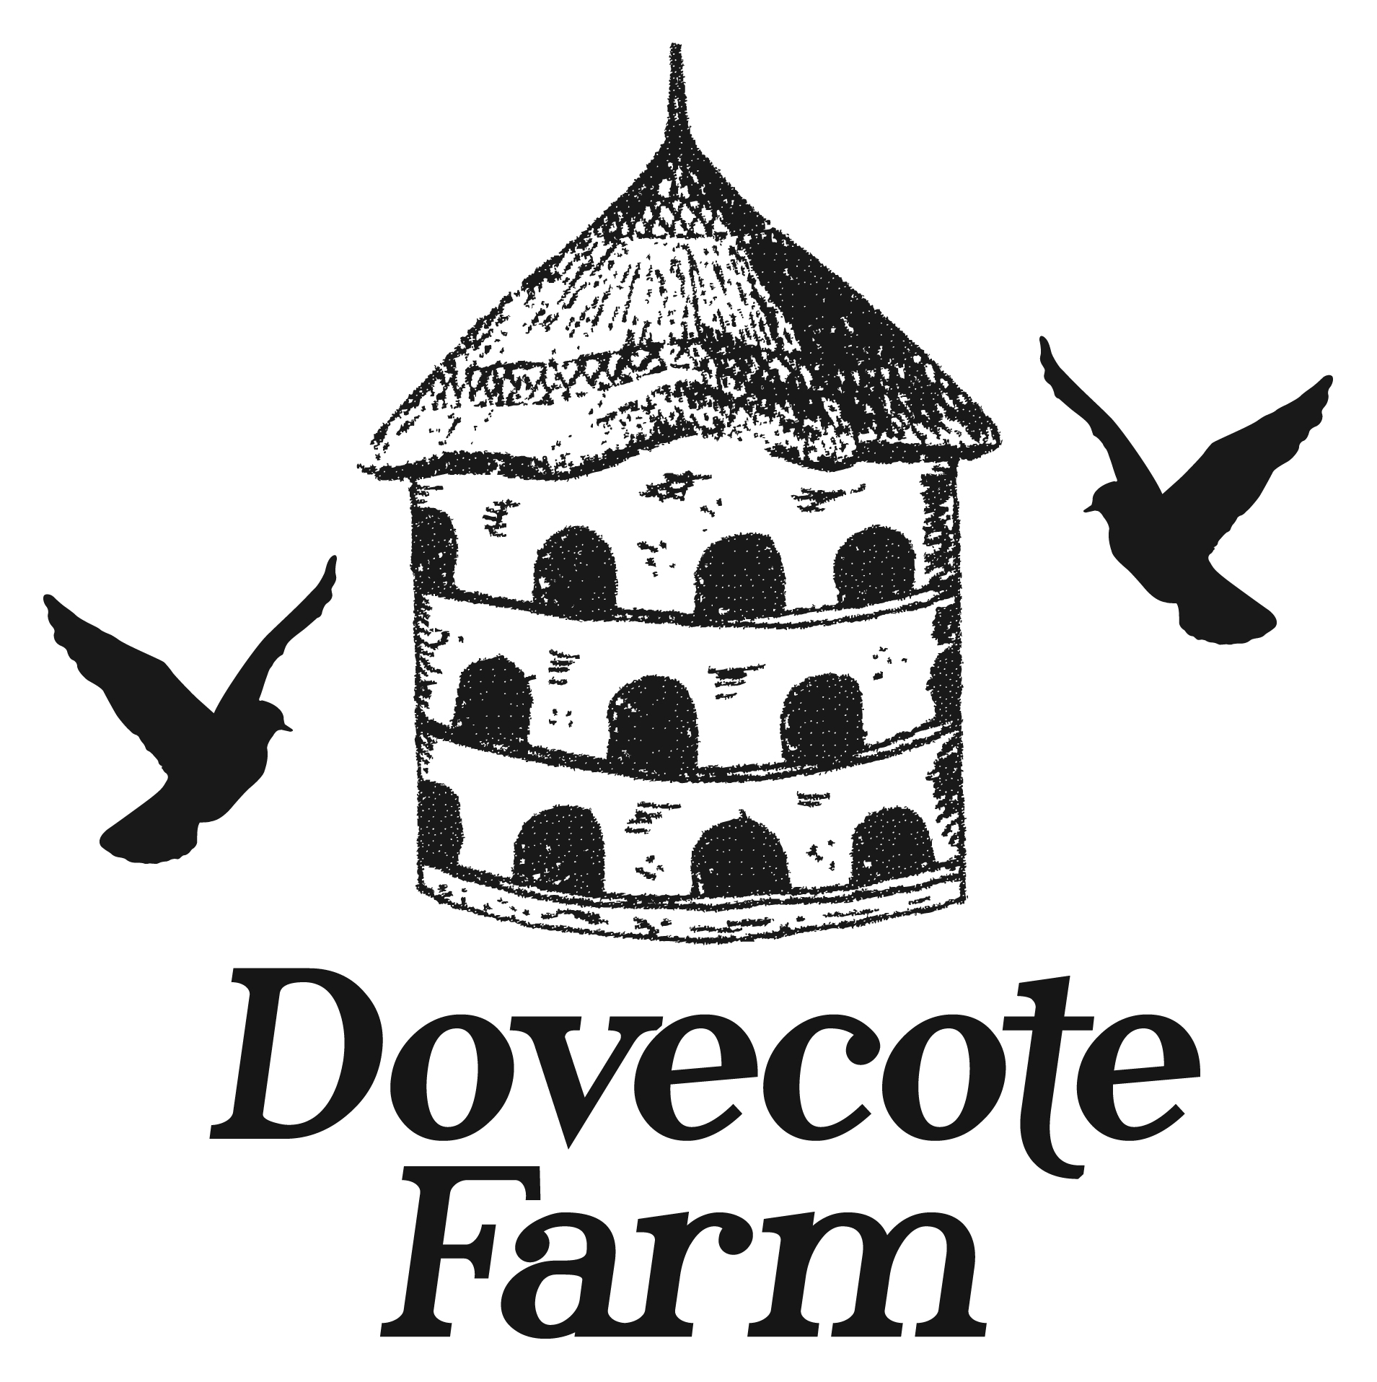
The Dovecote Buttery
High Tea
Bookings Only – 3pm to 5pm
Please advise on any dietary requirements at the time of booking
High Tea £16.50
High Tea with Prosecco £20.50

Sandwiches
Please choose three for your party from the following selection:
Cheese & Farmhouse Pickle
Tuna Mayonnaise and Cucumber
Egg Mayonnaise with a hint of White Truffle
Smoked Salmon and Cream Cheese
Brie and Red Onion Chutney
Tomato and Basil
Ham and Wholegrain Mustard

Followed By
An assortment of sweet delights, a scone with homemade homegrown strawberry jam and clotted cream and a handmade Belgian chocolate
Terms and Conditions
Please specify sandwich fillings and dietary requirements on booking
Coffee and Tea refillable
Confirmation required 48 hours before booking. Absent party members after confirmation to be charged full price
Payment in full required 48 hours before booking to secure table

